Name | Atharva Jadhav
Roll no | 24204A0034
Batch | 02
Subject name | Python Programming & Data Structure
Teacher Name | Ms. Rasika Patil

Experiments | 9
Title | Develop python program to define class Student with data members (Roll no, Name, Course, Percentage) as input and then print the details.

Programming Questions with Answer
1 | Program to create a Student class and display details
SCRIPT | Define the Student class  class Student:  def __init__(self, name, age, roll_number, grade):  self.name = name  self.age = age  self.roll_number = roll_number  self.grade = grade  # Method to display student details  def display_details(self):  print("Student Details:")  print(f"Name: {self.name}")  print(f"Age: {self.age}")  print(f"Roll Number: {self.roll_number}")  print(f"Grade: {self.grade}")  Create an object of the Student class  student1 = Student("Alice", 16, 101, "A")  Call the method to display details  student1.display_details()
OP | 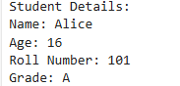
2 | Program using constructor to initialize student details
SCRIPT | Define the Student class  class Student:  # Constructor to initialize student details  def __init__(self, name, age, roll_number, grade):  self.name = name  self.age = age  self.roll_number = roll_number  self.grade = grade  # Method to display student details  def display_details(self):  print("Student Details:")  print(f"Name: {self.name}")  print(f"Age: {self.age}")  print(f"Roll Number: {self.roll_number}")  print(f"Grade: {self.grade}")  Create student objects using the constructor  student1 = Student("John", 17, 101, "A")  student2 = Student("Emma", 16, 102, "B")  Display details of students  student1.display_details()  print() # Blank line for separation  student2.display_details()
OP | 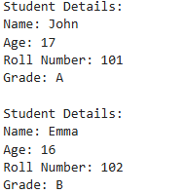
3 | Program to take multiple student objects
SCRIPT | Student class definition  class Student:  def __init__(self, roll_no, name, course, percentage):  self.roll_no = roll_no  self.name = name  self.course = course  self.percentage = percentage  def display(self):  print("Roll No:", self.roll_no)  print("Name:", self.name)  print("Course:", self.course)  print("Percentage:", self.percentage)  print("-------------------------")  # List to store student objects  students = []  n = int(input("Enter number of students: "))  for i in range(n):  print("\nEnter details of student", i + 1)  r = int(input("Roll Number: "))  nme = input("Name: ")  c = input("Course: ")  p = float(input("Percentage: "))  s = Student(r, nme, c, p)  students.append(s)  # Display all students  print("\n--- Student Details ---")  for s in students:  s.display()
OP | 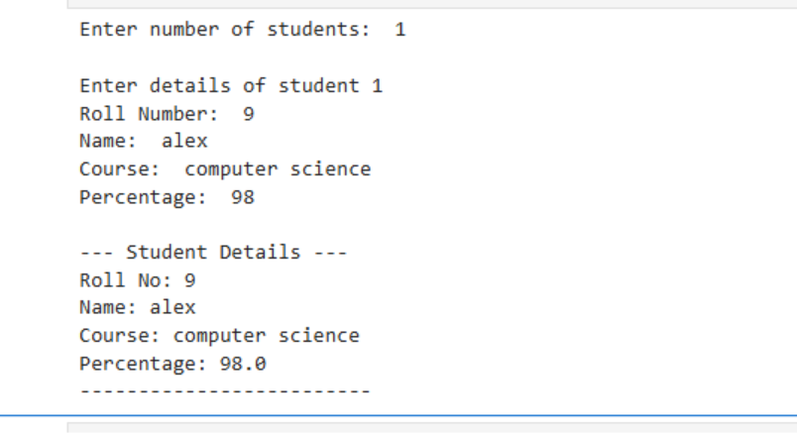
Debugging Questions with Corrected Answers
1 | Debug the following code  Wrong code:  class Student  def __init__(self):  self.name = "Amit"
OP | Error: SyntaxError: invalid syntax  Correct code: class Student:  def __init__(self):  self.name = "Amit"
2 | Debug the following code  Wrong code:  class Student:  def show():  print("Hello")  obj = Student()  obj.show()
OP | Error: TypeError: show() takes 0 positional arguments but 1 was given  Correct code: class Student:  def show(self):  print("Hello")  obj = Student()  obj.show()
Conclusion | - Object Oriented Programming helps in organizing data using classes and objects  - Constructors (__init__) initialize object data at creation time  - Methods are used to perform operations on object data  - Creating multiple objects allows handling multiple student records efficiently  - This program demonstrates practical use of OOP concepts in Python
Performance Indicators |  | Teachers Dated and Signature
Process Related  (15 M) | Product Related  (10 M) | Total (25 M)

